PLAN FOR MY PROJECT;
DESIGN AND IMPLIMENT AN APPLICATION FOR CAR RENTING BUYING CASE IN DOUALA (I,II,III,IV,V,VI)

1.Context and motivation
INTRODUCTION

In Cameroon, Douala is the economic capital of Cameroon, which is divided into districts such as Douala 1,2,3,4,and 5. Transportation is a major challenge due to unreliable public transport, traffic congestion, and limited access to private vehicles. Many people need cars for business, to travel, or for personal use but for rent or purchase is often difficult and not well organized.
So, the motivation for this project come from the difficulties people face when trying to rent or buy cars in Douala. Many transactions are done informally, without digital platform which lead to lack of trust, time loss, and limited choices. This inspired the development of a digital application that simplifies the process, improves accessibility.

2.The problematic of my project
From my observation I have notice that people may fall in the following problems
. No central place to find cars
. Time wasted moving from one place to another
. Risk of scam or unreliable sellers
. Limited choices resulting to difficulties in comparing options
. poor communication between buyer and seller

3. General Objective
The general objective of this project is to develop and design an efficient and user-friendly digital application that will connect car owners and customers, making it easier to rent and buy cars in the town of Douala particularly in Douala zone 1-6 thereby improving accessibility, transparency, and reliability.
Specific Objectives
- To allow users to create accounts
- To display available cars
- To enable booking and purchasing
- To provide secure communication
- To establish a verification system for both renters and owners

4. Literature review of the existing solutions
Several digital platforms have been developed worldwide to facilitate car renting and buying. These platforms allow users to search for vehicles, compare prices, and connect with sellers or rental agencies. However, their availability and adaptation to the local context of Douala remain limited.

Examples of existing applications include;
- Autotrader
This is an international platform for buying and selling cars.
It strengths includes;
. There is detailed car listings
. Price comparison

Limitation
. Mostly used outside Africa
. Not adapted to Douala context
. No renting feature
- Turo
This is an application which allow people to rent car from others.
Strengths
. Peer-to-peer renting ie, people rent items like car directly to other people, without a company owning the car.
. Flexible booking
Limitations
. Not available cars
. It requires strong digital infrastructure

Some of the gaps I have identified are;
Despite the existence of these platforms, there is no dedicated application tailored to the specific needs of users in Douala. Most solutions are either not available locally, not adapted to the economic environment, or do not combine both car renting and buying in a single platform.

Therefore, there is a need to design and implement a localized application that integrate both car renting and buying services, adapted to the realities of Douala (Douala 1-6), ensuring accessibility, trust, and ease of use.

5. Requirements Gathering
WHAT IS REQUIREMENTS GATHERING ALL ABOUT?
Requirement gathering is the process of collecting and analyzing user needs in order to design an effective car renting and buying application adapted to the context of Douala

WHO WILL USE MY STSTEM?
*Customer (User)= rents or buys cars
*Car Owner= lists cars for rent or sale
*Administrator= manages the system

6. Functional Requirements
This represent what my system must do. For example;
*The system shall allow users to create an account
* The system shall allow users to log in
* The system shall display available cars
* The system shall allow users to search cars by location (Douala 1-6)
* The system shall allow users to rent and buy a car
* The system shall allow communication between users and owners
* The system shall allow booking and reservation

Non-Functional Requirements
These are how systems should behave. For example;
*The system should be easy to use
*The system should be fast and responsive
*The system should be secure
*The system should be available 24/7
*The system should support mobile devices

Data Requirements
The type of information my system will store:
~User information
~Car details
~Booking details
~Payment information

Requirement Gathering Methods
How did I get my information: Through observation (seeing problems in Douala), online research.
ENTITY RELATIONAL DIAGRAM (ERD)

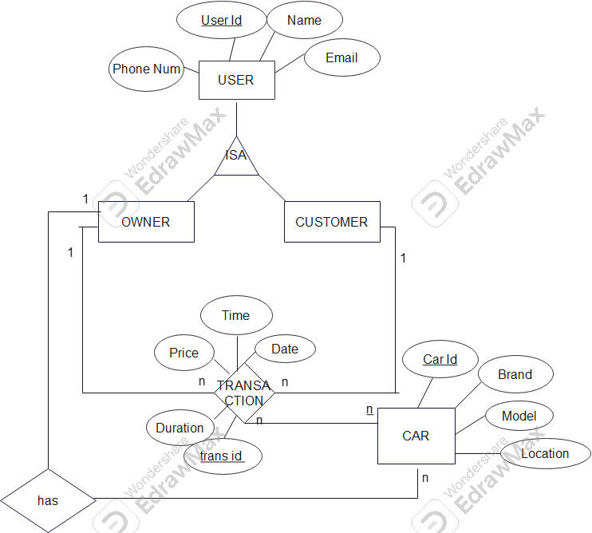

RELATIONAL MODEL
User (user id, name, email, phone num)
Owner (user id)
Customer (user id, #car id)
Car (car id, brand, model, location, #user id)
Rent (#user id, #user id, car id, price)
Sell (#user id, #car id, #user id)

